Light

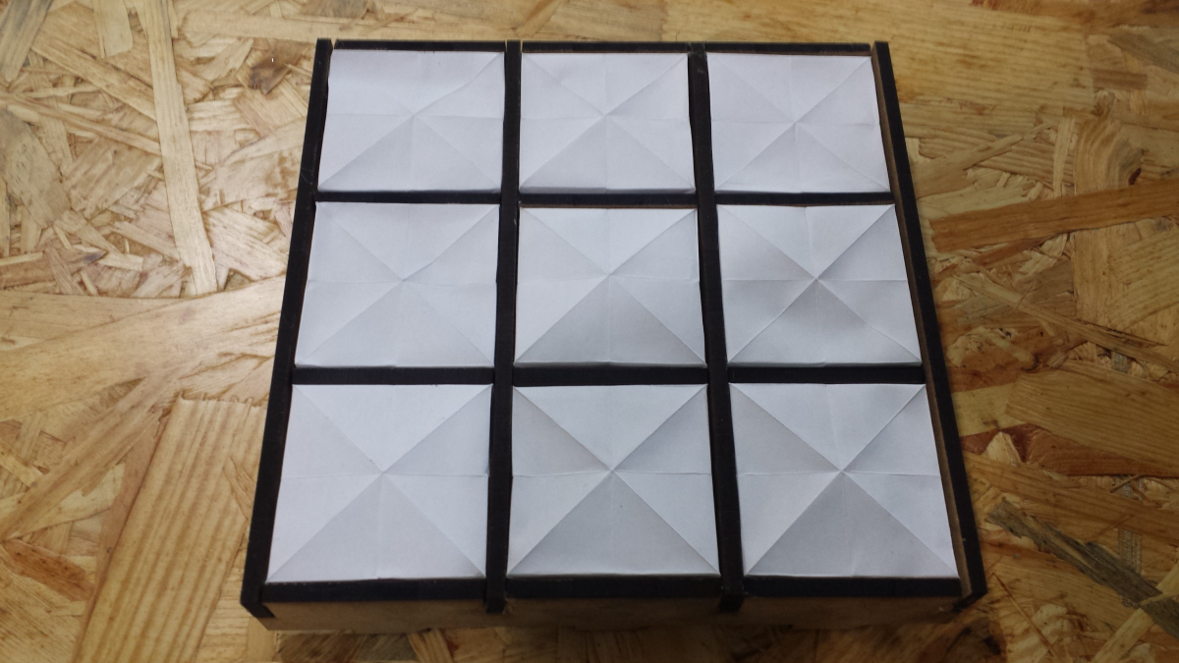

About:

For the final project of the core course Light, I aimed to highlight the element of my Asian heritage in a technological design and to demonstrate the use of affordable materials to create aesthetic piece.

design fusion between origami and multi-colored LED strip. The use of origami as light diffuser emphasis the fold and crease of

I feel that the addition of origami fold and crease lines in the light diffuser provides an extra feeling of organization and order. The interplaly between the charred Medium density fibreboard (MDF) from laser cutting and white origami paper, forms beautiful minimalist.